

NATIONAL POLICE COMMISSION

**PHILIPPINE NATIONAL POLICE, POLICE REGIONAL OFFICE CALABARZON**

**CAVITE POLICE PROVINCIAL OFFICE**

**CARMONA MUNICIPAL POLICE STATION**

J.M. Loyola Street, Brgy. Maduya, Carmona, Cavite

February 2022

2022-02-045

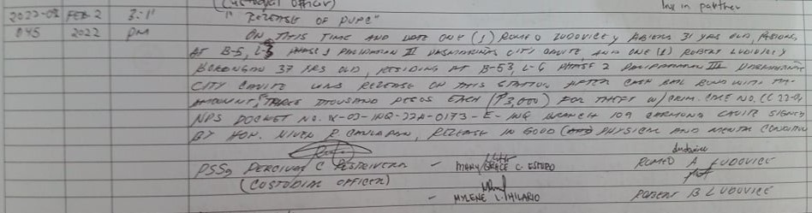

2022-02-055

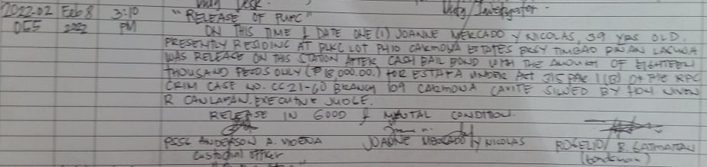

2022-02-059

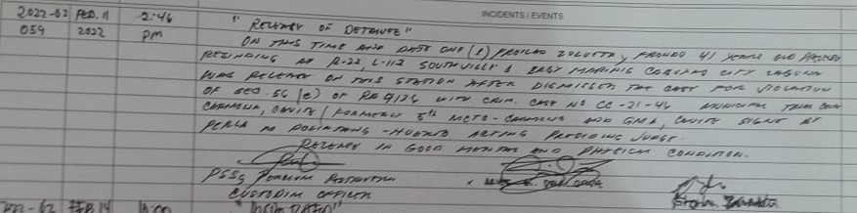

2022-02-062

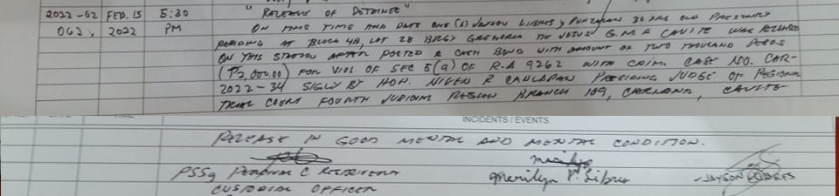

2022-02-68

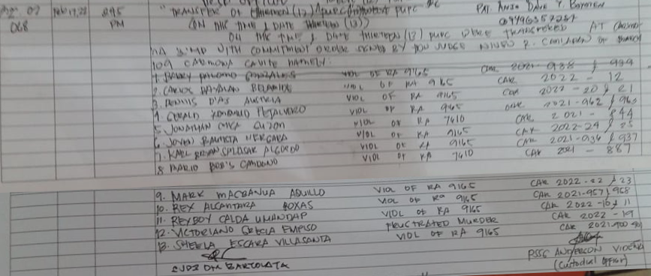

2022-02-070

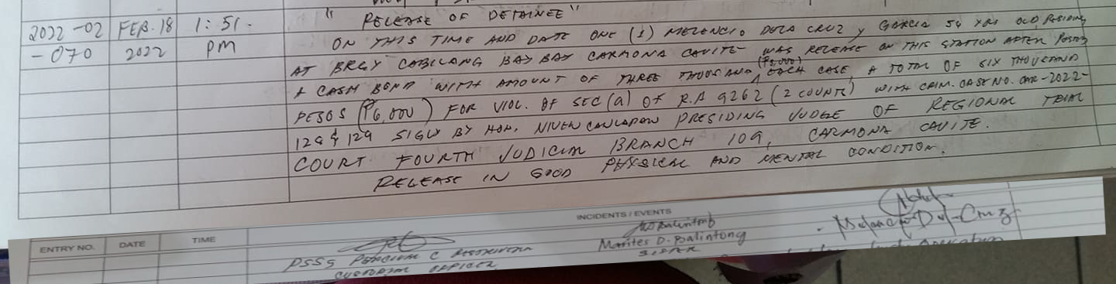

2022-02-073

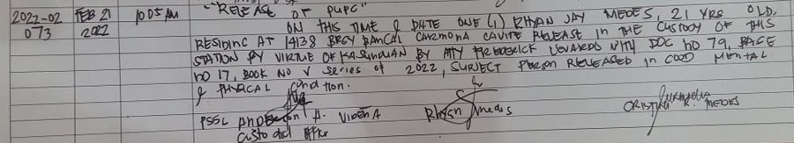

2022-02-076

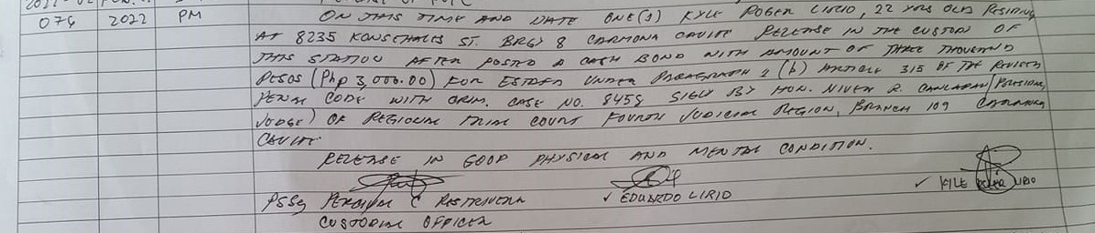

2022-02-077

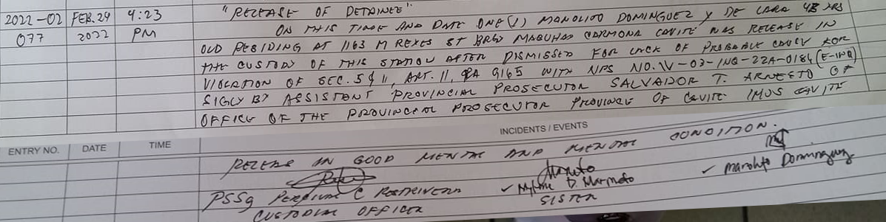

2022-02-089

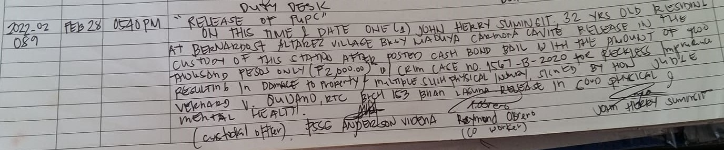

2022-02-090

